Toolbox Talk No. 73 *
Eye Injury

Of all our senses, the one most precious perhaps is our sense of sight. Yet each year thousands of us suffer eye injuries that impair our vision or deprive us of our sight altogether.

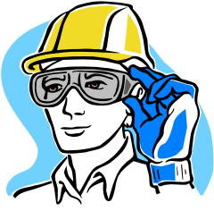
These injuries are to a large extent, avoidable, in fact, over 90% of all eye injuries can be prevented by following established safety guidelines and using the appropriate protective eyewear for the tasks we perform.

Among the most common eye hazards are flying particles, a hazard typical of many machine operations such as grinding/using cut-off saws. Dusts (such as wood, metal, and other airborne particles), sparks (common in welding), and fumes and splashes (from molten materials or chemicals) can all cause eye injury unless appropriate protective eyewear is worn. Often it may involve activities that you are not involved in and are simply “passing by”. Always be aware of activities on your site that could cause eye injury.

Quite often an eye injury will occur and the individual will only feel a very minor irritation, and think nothing of it and simply rub their eye and carry on working, this can make the situation worse. If you get ingress to your eye see your first-aider, never try and remove it yourself.

Please take note of the following guidelines:

- Be alert to the eye hazards in your workplace.

- Wear the appropriate protective eyewear – glasses, goggles, and/or hoods, face shields and welding helmets – provided by your employer for the specific hazards you face.
- Remember that regular eye glasses or contact lenses will not protect you from eye hazards – if you must wear corrective lenses, then you’ll need to wear protective eyewear over them.
- Check to make sure that your protective eyewear fits you properly and is clean and in good condition before and after use.
- Replace faulty eyewear immediately
- Follow established safety guidelines and any specific site rules relating to protective eyewear. Don’t go into an area where eye protection is mandatory unless you are wearing it.
- Know where the first-aid facilities are on your site.
- In the event of eye injury, get medical attention immediately.

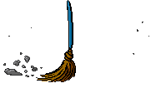

During summer months the problems with dust on sites is likely to increase, always maintain good housekeeping. In some instances it may be necessary to issue safety spectacles to wear for general use on site, to reduce the possibility of dust ingress to the eye, if so then please be reminded that they should not be used for activities that require a greater degree of protection (grinding and using cut-off saws are examples).

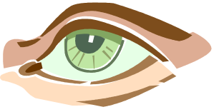
“YOU ONLY HAVE ONE PAIR OF EYES” – PROTECT THEM!

